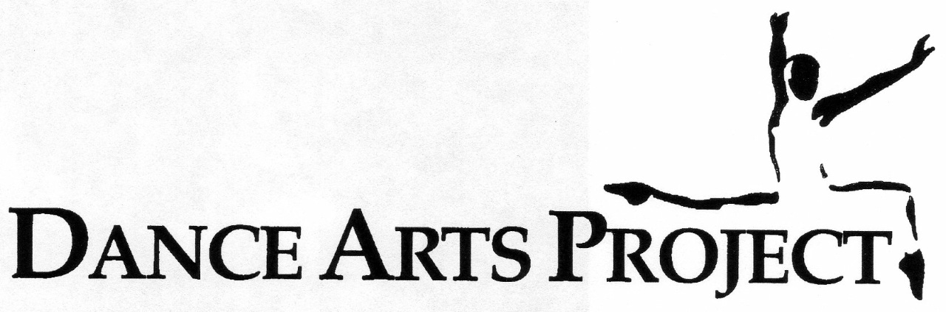

Operational manual

Welcome to Dance Arts Project! We believe in non-competitive artistic experssion. We believe that each child is a natural dancer, and we strive to encourage and foster confidence through dance.

Registration

Pre-registration for the following school year takes place in early June, with priority given to returning students. New students are always welcome and have a designated registration day as well. Students can be signed up during the summer during any of Miss Michaela’s camps. Following summer camps, the next opportunity to register will take place in early September, before regular classes resume.

Additional students will only be accepted through December 1st.
Tuition is paid on a monthly basis, and due at the beginning of each month. We happily offer a discount for siblings. Our program runs for the entirety of 10 months, from September to June.

Levels, placement & requirments
Dance Arts Project’s program placement is dictated by each student’s age until the age of 12. Above the age of 12, students must meet requirements to progress.
Creative Movement | Ages 4-5 | 1 class per week
Pre-Ballet | Ages 6-7 | 1 class per week
Level 1 (Ballet & Modern) | Ages 8-9 | 1 or more classes per week
Level 2 (Ballet & Modern) | Ages 10-11 | Two ballets required to advance

Tech | Ages 12+ | For students who don't meet requirements or are new to ballet. Two Tech classes can catch you up to the other students in levels above you (at the teachers' discretion).
Level 3 (Ballet & Modern) | Ages 12+ | Must have taken a minimum of two Level 2 Ballets. Must take a minimum of three Ballet classes to continue.
 | 1st year: | Three ballets in Level 3; pre-requisite to Pointe*
 | 2nd year: | Three ballets minimum; pre-requisite to Pointe*
Level 4 (Ballet & Modern) | Ages 14-15 | By invitation only. Four ballets minimum, more classes encouraged. Students have the option to stay in Level 3 classes (Ballet, Modern, and/or Tech)
Level 5 (Ballet & Modern) | Ages 16-17+ | By invitation only. Four ballets minimum, more classes encouraged.
*Students must be the minimum age of each level by end of the calendar year. For example, if a student is entering a Creative Movement class for the 19/20 school year, that student must have turned four by the end of December 2019.

attendance
Dance Arts Project’s program runs similarly to the school-year schedule– classes begin in September and run through June. We offer dance camps during the summer, as opposed to regular classes. The studio is closed for the entire month of August.
Regular attendance helps each dancer progress. Inevitably, dancers must miss a class, but we encourage each dancer to “make-up” their missed classes in a class of the same level or lower. Too many missed classes following February 1st can affect show participation.
The most crucial time for attendance is the three months prior to the show. If a student misses more than one or two classes in this time frame, or misses several consecutive classes (especially in Level 3 and up), this can negatively affect the timing and spacing of each dance, which can be incredibly frustrating for other dancers in the class. If you miss more classes than is approved by the director, you will be excused from participating in the performance.
Once a student has progressed to pointe, per the teachers’ recommendation, it is advised that they wear their pointe shoes in every ballet class following their first year en pointe. Attendance will be taken with special consideration that each dancer wears their pointe shoes for each class. Too many classes taken in flat shoes will result in a student losing their pointe shoes.
Timeliness is extremely important! Students should arrive in enough time before the start of each class to prepare for class.

dress code
Dance Arts Project’s dress code is liberal, but there is a dress code.
Ages 4-7 | Dancewear, such as a leotard, tights or socks, and a skirt, not play clothes. Each dancer should have real ballet slippers. Hair should be in a ponytail or pulled away from the students' face.
Ages 8-11 | Dancewear should include a leotard and tights. Skirts and dance shorts are optional. Ballet slippers are worn for both Modern and Ballet class. Hair should be worn in a bun for Ballet class. All students will learn to do a ballet bun in Level 1. Hair should be in ponytail or pulled away from the face for Modern.
Ages 12+ | A leotard and tights are required for class. Skirts and dance shorts are optional. Hair should be worn in a bun for Ballet class. Hair should be in ponytail or pulled away from the face for Modern.

For dancers ages 12 and up: See above. Leotards should be worn alone– please no baggy clothes, visible underwear, or excessive jewelry. Tights should be pink, worn underneath the leotard, and free from rips and tears. Black tights can occasionally be worn outside of the leotard, but should not be worn routinely. Leotards and tights should be washed after each use, and use of deodorant is encouraged. Dancers should take great care of their appearance for class and be proud of how they present themselves in class!
A bun is mandatory for ballet class for ages eight and up. There is a special way that ballet dancers do their buns, and all ballet students will learn this skill in Level 1! Dancers must bring their own hairbrush, hairbands, and hairpins to every ballet class.

Respect
Respect: each other, the teachers, and yourselves. Dance Arts Project is a non-competitive dance school where we encourage and respect each other. Any kind of bullying or disrespect will be addressed. Disrespectful behavior can result in a student being dismissed from the school.
Phone Policy: Phones should be turned off and left in your dance bag during class. We encourage students to make friends with the dancers around them while in the studio. Please no filming or taking pictures in class without permission.
Parking: Dance Arts Project wants to continue being good neighbors! Please be aware that there should be no double-parking and blocking driveways both before and after class.
Chestnut Encinal Market: Students ages 12 and up are allowed to go to the store, if they use the crosswalk and dress appropriately. Please know that there have been a couple of incidences of shoplifting over the years. There are cameras throughout the store; if students are caught shoplifting, both their parents and Miss Michaela will be informed.

the show
Every year, we have a dance recital in June for the whole dancing school. Every class is a dance in the show. Parents are responsible for the cost of their student’s costume, tickets, and recital fee, when applicable. Students do not have to participate in the show, but teachers must be informed of a student not participating by February 1st.
In the event that a student cannot participate in the show, they can still participate in class as a “stunt dancer”! Learning the choreography from many vantage points by taking the place of an absent student is extremely beneficial for both the student and the class.
Dancers ages 12 and up are required to participate in Tech Week, which takes place in the studio the four days before Dress Rehearsal. Tech Week attendance is required to participate in show.
Dress rehearsal is mandatory for a student’s participation in The Show. More information regarding show times, costumes, tickets, etc. will be made available at the studio in February.
•••
To our dancers:

We wish you the strength to face challenges with confidence along with the wisdom to choose your battles carefully. We wish you adventure on your journey and may you always stop to help someone along the way. Listen to your heart and take risks carefully. Remember how much you are loved. We are so proud of you, and don’t forget to dance in the rain.

Love,
Miss Michaela, Miss Erin, Miss Eva, Mr. Aidan, and Miss Marina

